Accessible
bar graphs
In html and CSS
Adina Halter
Sr. Product Manager, Accessibility
Comcast

Problem
TABLES VS GRAPHED TABLE DATA

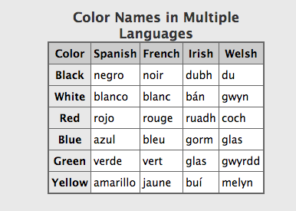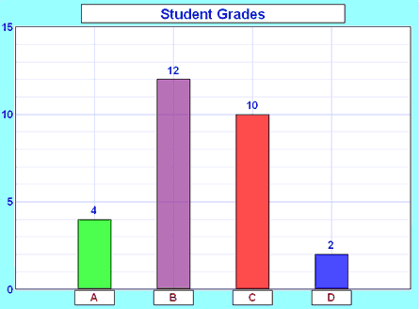

Slide notes:
(Well-formed) tables triangulate headings in screen readers
Bar charts without table relationships:
This example reads ”Student Grades, 15, 10, 5, 0, 4, 12, 10, 2, A, B, C, D”. How many students got a grade of B?
GRAPHS ARE VISUAL

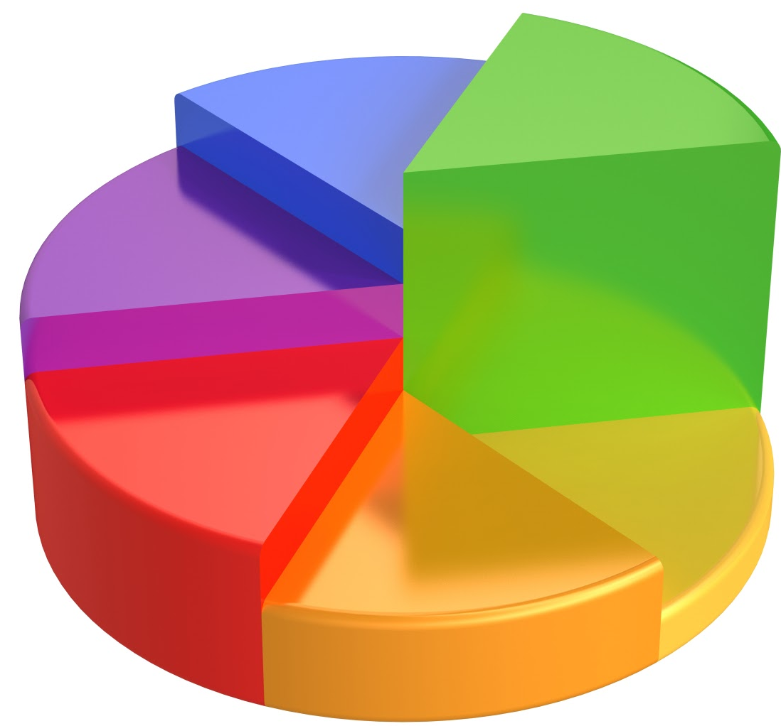

Slide Notes:
Graphs can be beautiful works of visual art.
But often the more beautiful they are the more chance they will be an image without text reference to what they represent.
TABLES ARE BORING…

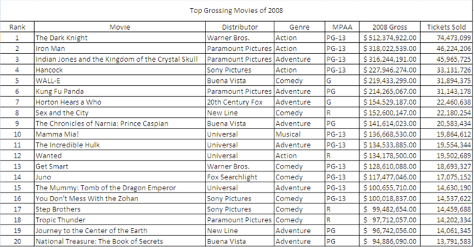

Slide Notes:
On the flip side, tables are visually BORING…
…EVEN WHEN YOU ADD COLOR

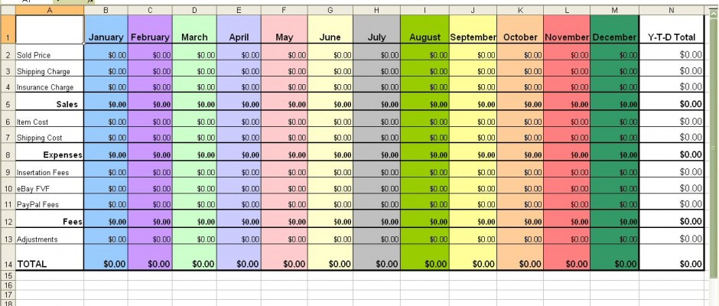
Current Methods
IMAGE WITH DESCRIPTION

- Triangulate data?
- Descriptive?
- Maintenance
Slide notes:
- Will not be able to triangulate the data
- Often not descriptive enough
- Need to rewrite as data changes
- This bar graph image has an alt tag: “bar graph of money invested in 2010, 2011 and 2012”. Not very descriptive.
- The summary attribute says “The bar graph shows that every year between and including 2010 and 2012, the money that has been invested has decreased 50%.
- Again: not very descriptive AND Inaccurate. No one took the time to rewrite the summary when the data changed.
GRAPH + TABLE

- 2X code
- 2X real-estate

Slide notes:
- Twice as much code to maintain per graph
- Double the real estate

JAVASCRIPT PLUGINS

- Milliseconds count
- JSON data?
- Accessible?
- Support?

Slide notes:
- Increased download time
- Data may need to be translated to JSON (loses the relationship)
- Rendering doesn’t mean accessibility
- Is plugin support maintained through lifecycle?

Our Solution
OUR SOLUTION

- HTML
- CSS
- No JS
- It’s only a table!!
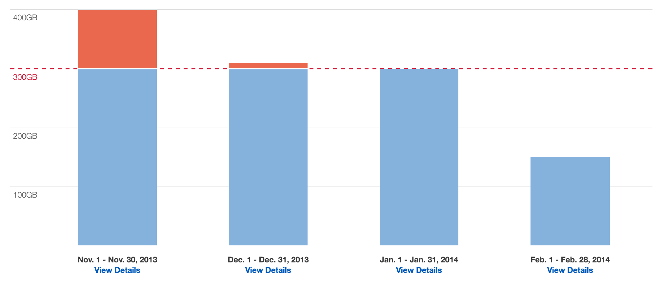

SOLUTION EXAMPLE

http://haltersweb.github.io/accessibility/barchart.html
STUMBLING BLOCKS

- <thead>
- <tfoot>

Slide notes:
- How to place thead as labels below data
- Tfoot is not supported in screen readers

Resources
LINKS AND CONTACT INFO

Helpful links:
- Link to solution: http://haltersweb.github.io/Accessibility/barchart.html
- Link to powerpoint slides: http://haltersweb.github.io/Accessibility/slides/barchart.pptx
- Link to word version of slides: http://haltersweb.github.io/Accessibility/slides/barchart.docx
Adina Halter:
- Email: adina_halter@cable.comcast.com
- Twitter: @haltersweb

